**Certificate Issuance – Hyperledger Fabric**

We will be using FABRIC CA for issuing certificates for the Hyperledger Fabric Blockchain.

**Fabric CA comes us with two executable**

|  |  |  |
| --- | --- | --- |
| **#** | **Executable** | **Remarks** |
| 1 | fabric-ca-server | This service will be up and running for issuing certificates. This server maintains all the org information and the certificate details |
| 2 | fabric-ca-client | Using this executable, one can request for certificate |

**STEP 1: INSTALLATION**

Make sure the other prerequisite installations are complete

* git clone https://gerrit.hyperledger.org/r/fabric-ca
* make fabric-ca-server
* make fabric-ca-client

**STEP 2:**

**Initializing Fabric CA Server**

* fabric-ca-server init -c test/config.yaml -b admin:March2018

This will create a default config.yaml file with bootstrap username admin and password as March2018#

**Starting Fabric CA Server**

* fabric-ca-server -c test/config.yaml start

**Setting up CA certificates in Hyperledger Fabric network**

This document describes about setting up MSP (membership services) using FABRIC CA Server and FABRIC CA client

Let us take the below organization structure as an example

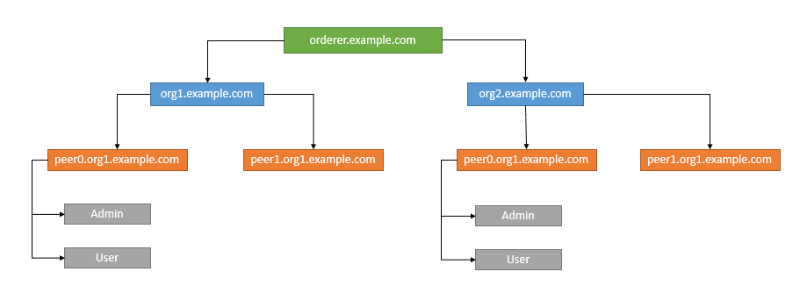

**STEP 1:**

In our example both orderer and Fabric CA Server is installed in the same machine

**Commands to Install**

* git clone https://gerrit.hyperledger.org/r/fabric-ca
* make fabric-ca-server
* make fabric-ca-client

**STEP 2:**

**Initializing Fabric CA Server**

**STEP 3:**

Let us set up the certification authority for the given organization structure